Unmasking the Domination System

In order to engage the Domination System as Wink has defined it, we need to be able to recognize it. That is the task Wink has set for himself in Part 1 of Engaging the Powers. This reading is from the last chapter of Part 1, “Unmasking the Domination System.” The first two parts of this chapter are titled “The Delusional Apparatus according to Revelation 12-13” and “The Manufacture of Idolatry according to Revelation 13.” If you enjoy reading Revelations, you will really enjoy reading Wink’s exegesis of Revelation 12-14. But, this not something I would impose on everyone. That is why this reading starts with the third part “The Delusional Assumptions” and adds the final part “Liberation from the Delusional System.”

Some things to keep in mind as you read these 10 pages:

- How eerily like today are the 1992 delusional assumptions!
- How both the oppressors and the oppressed need to be liberated.
- How have you internalized the delusional assumptions?
- He defines domination as more than a power relation, but as a spiritual state of being.
- We need to have a vision.
- What part of the book would you like to read next?

Bring your questions and key passages to the next Meeting of the New Story Group on Monday, February 26, 2018.
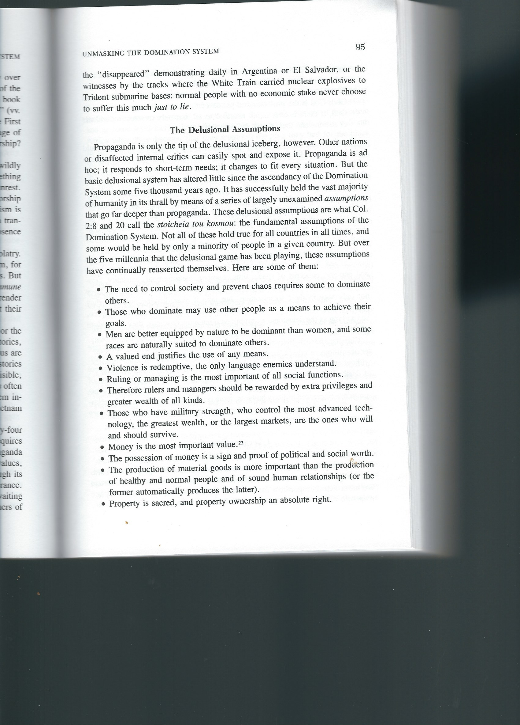
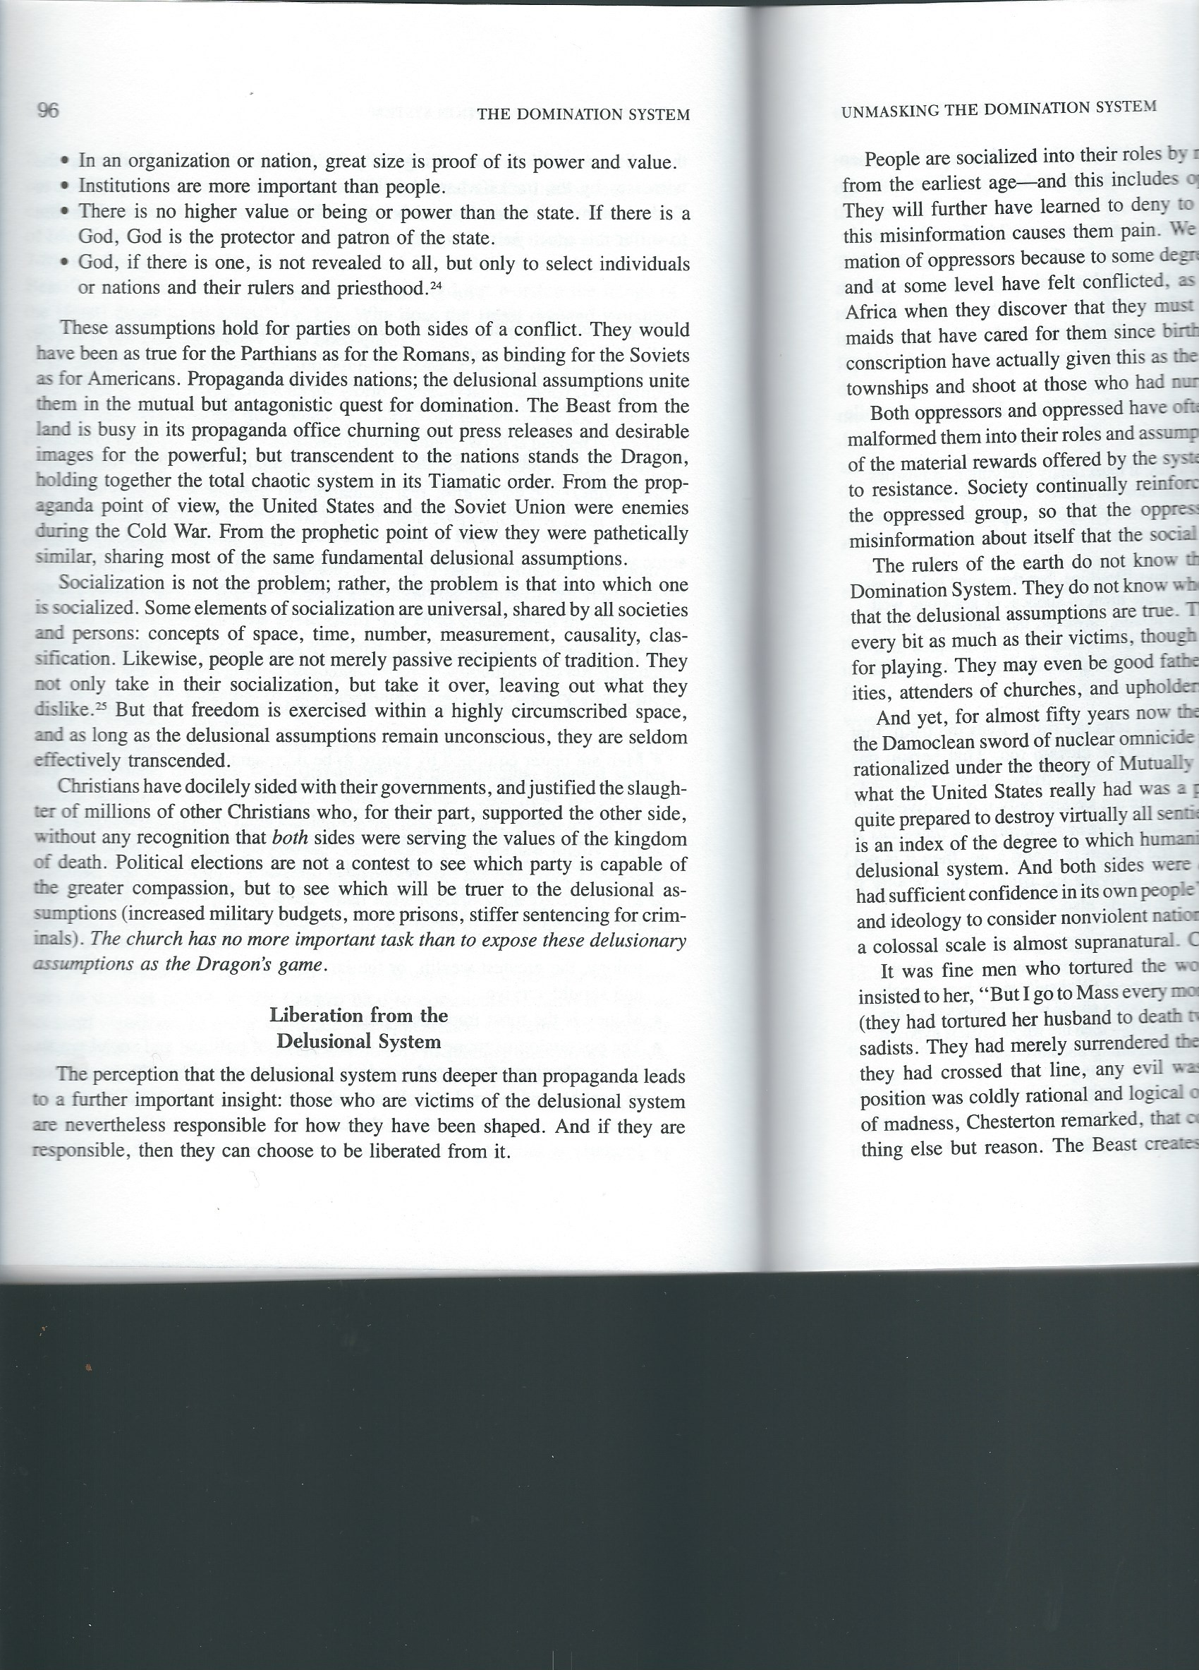
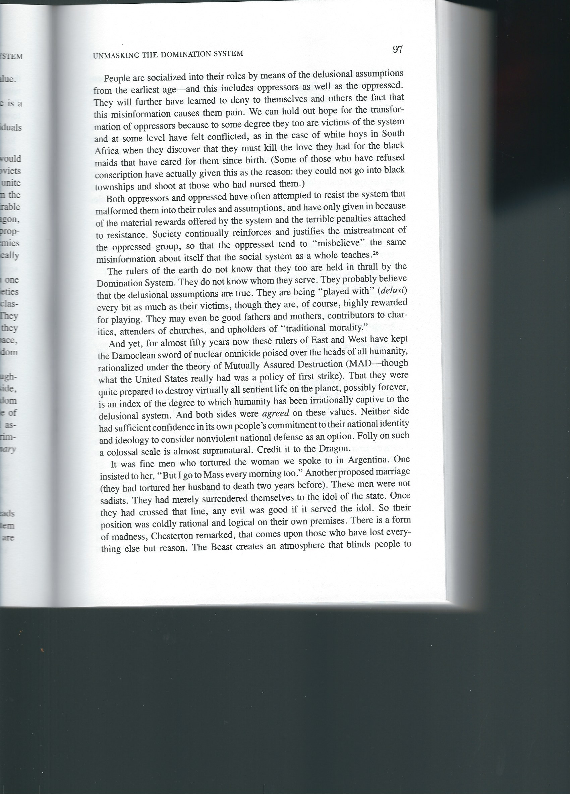
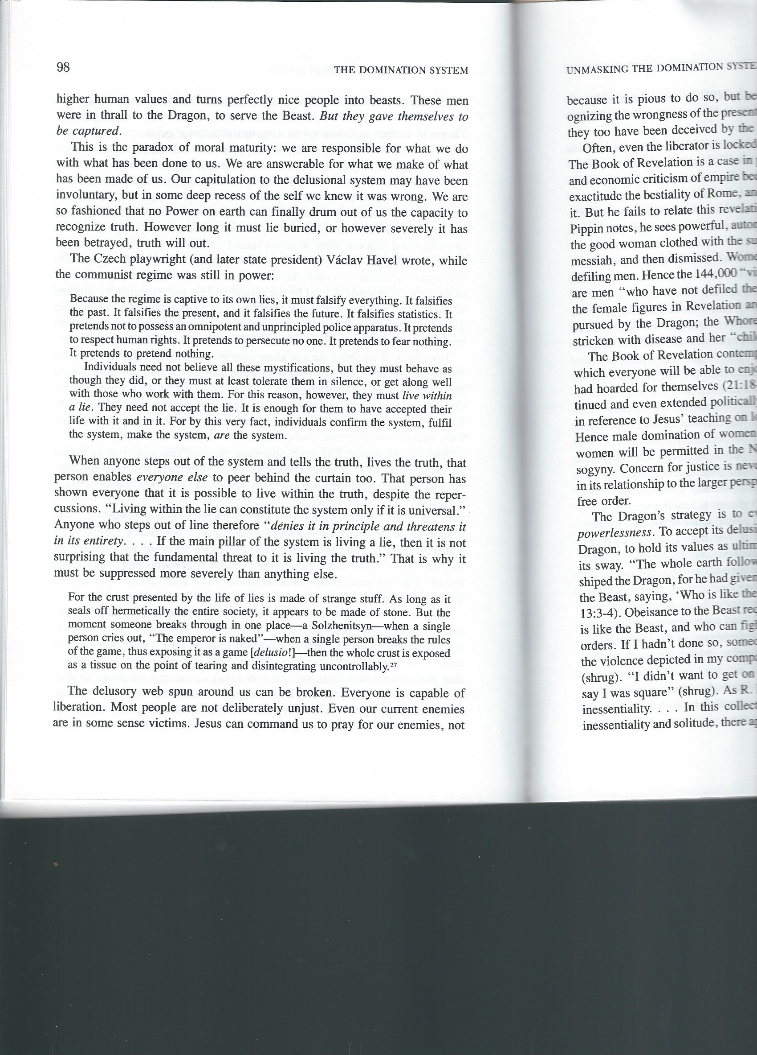
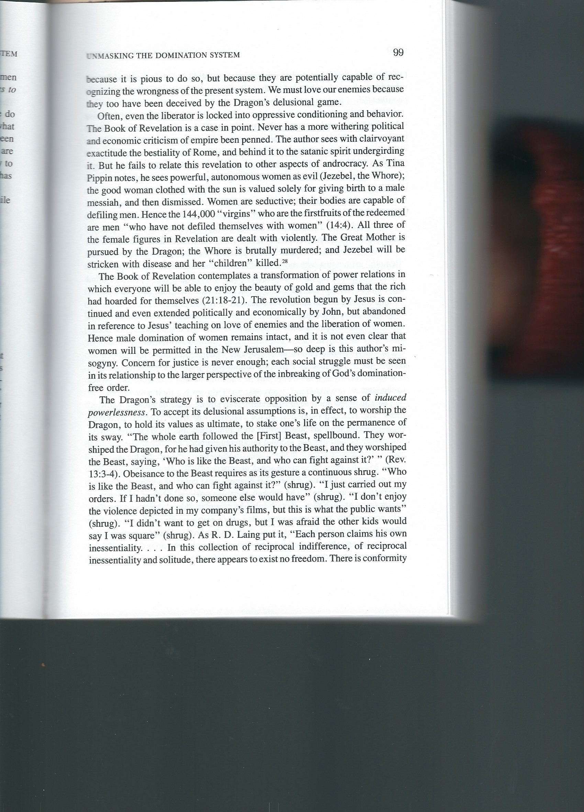
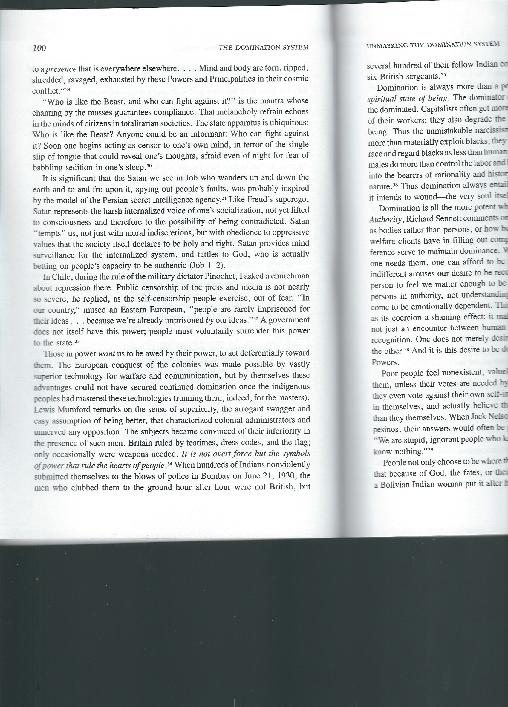
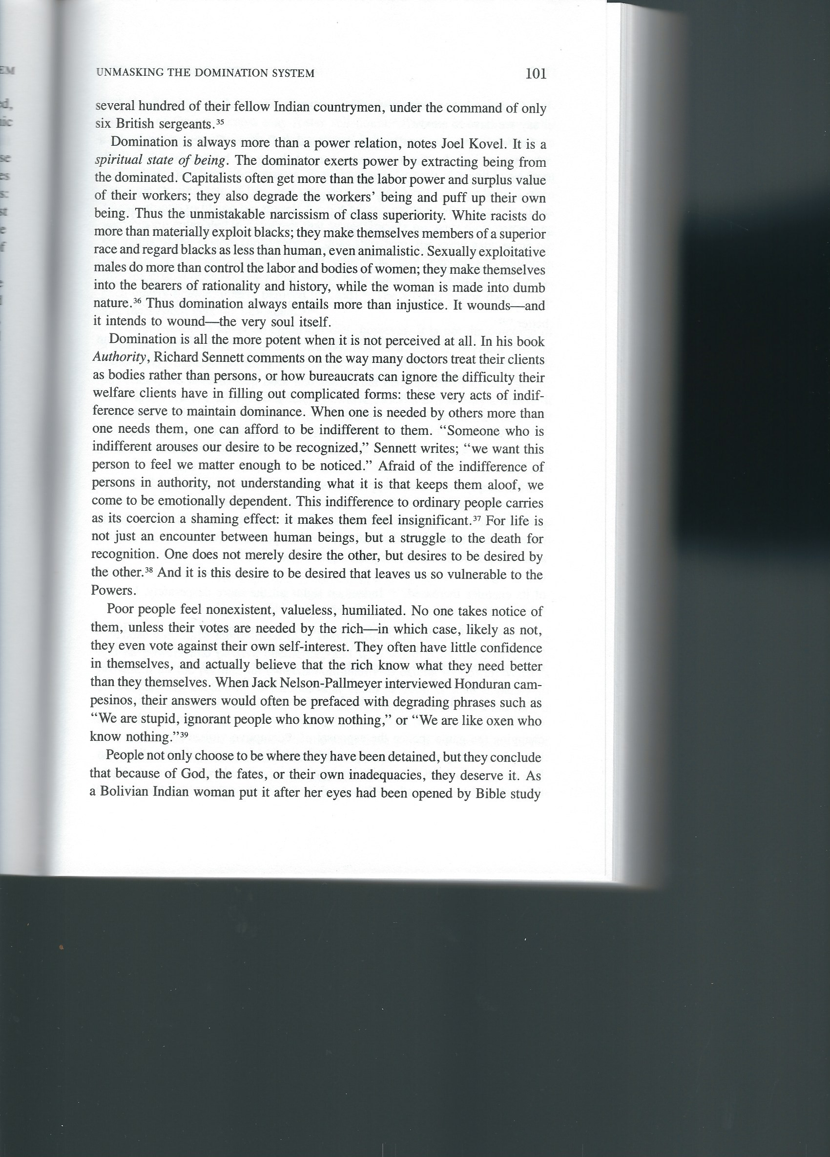
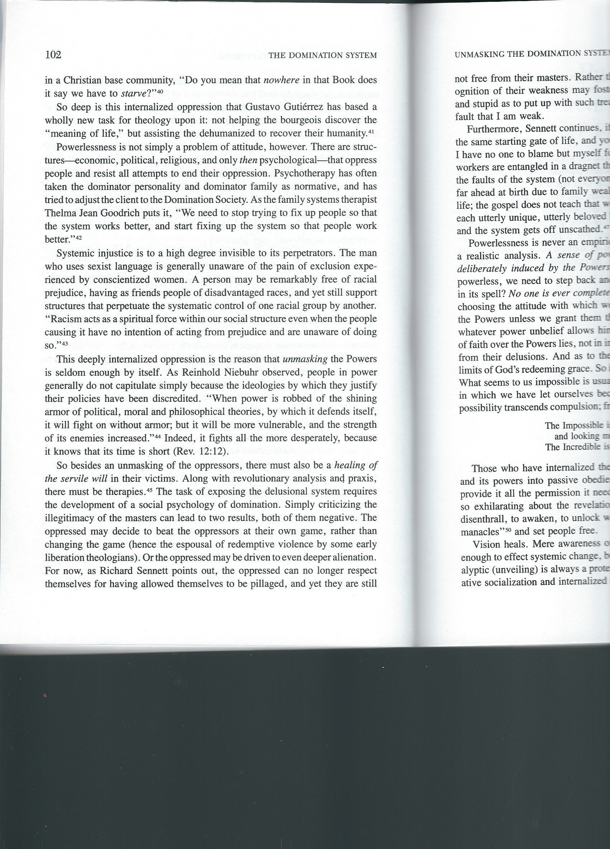
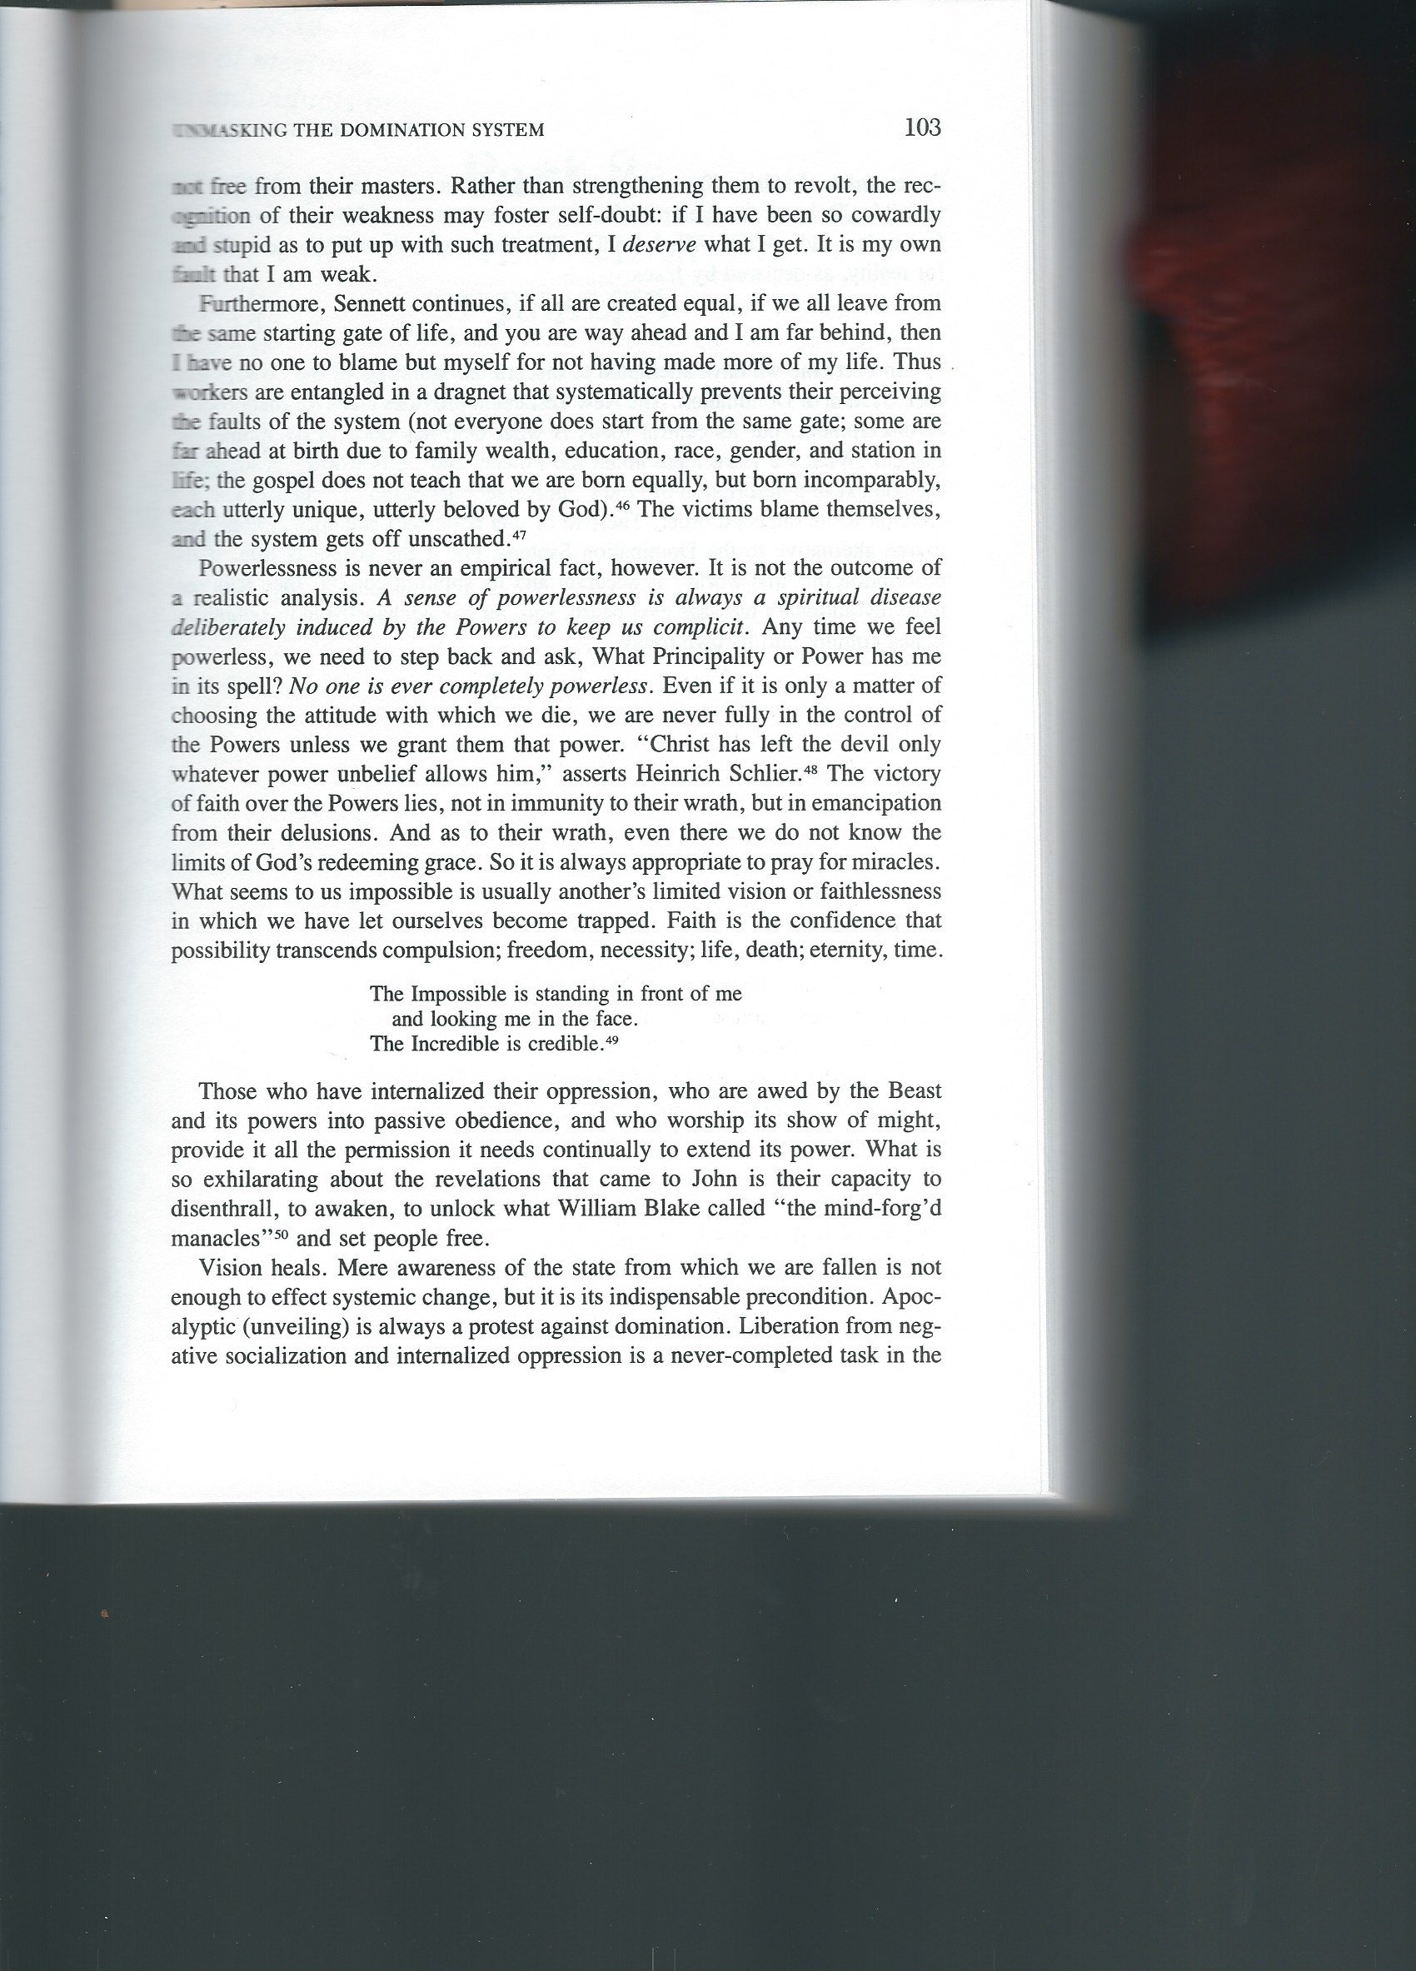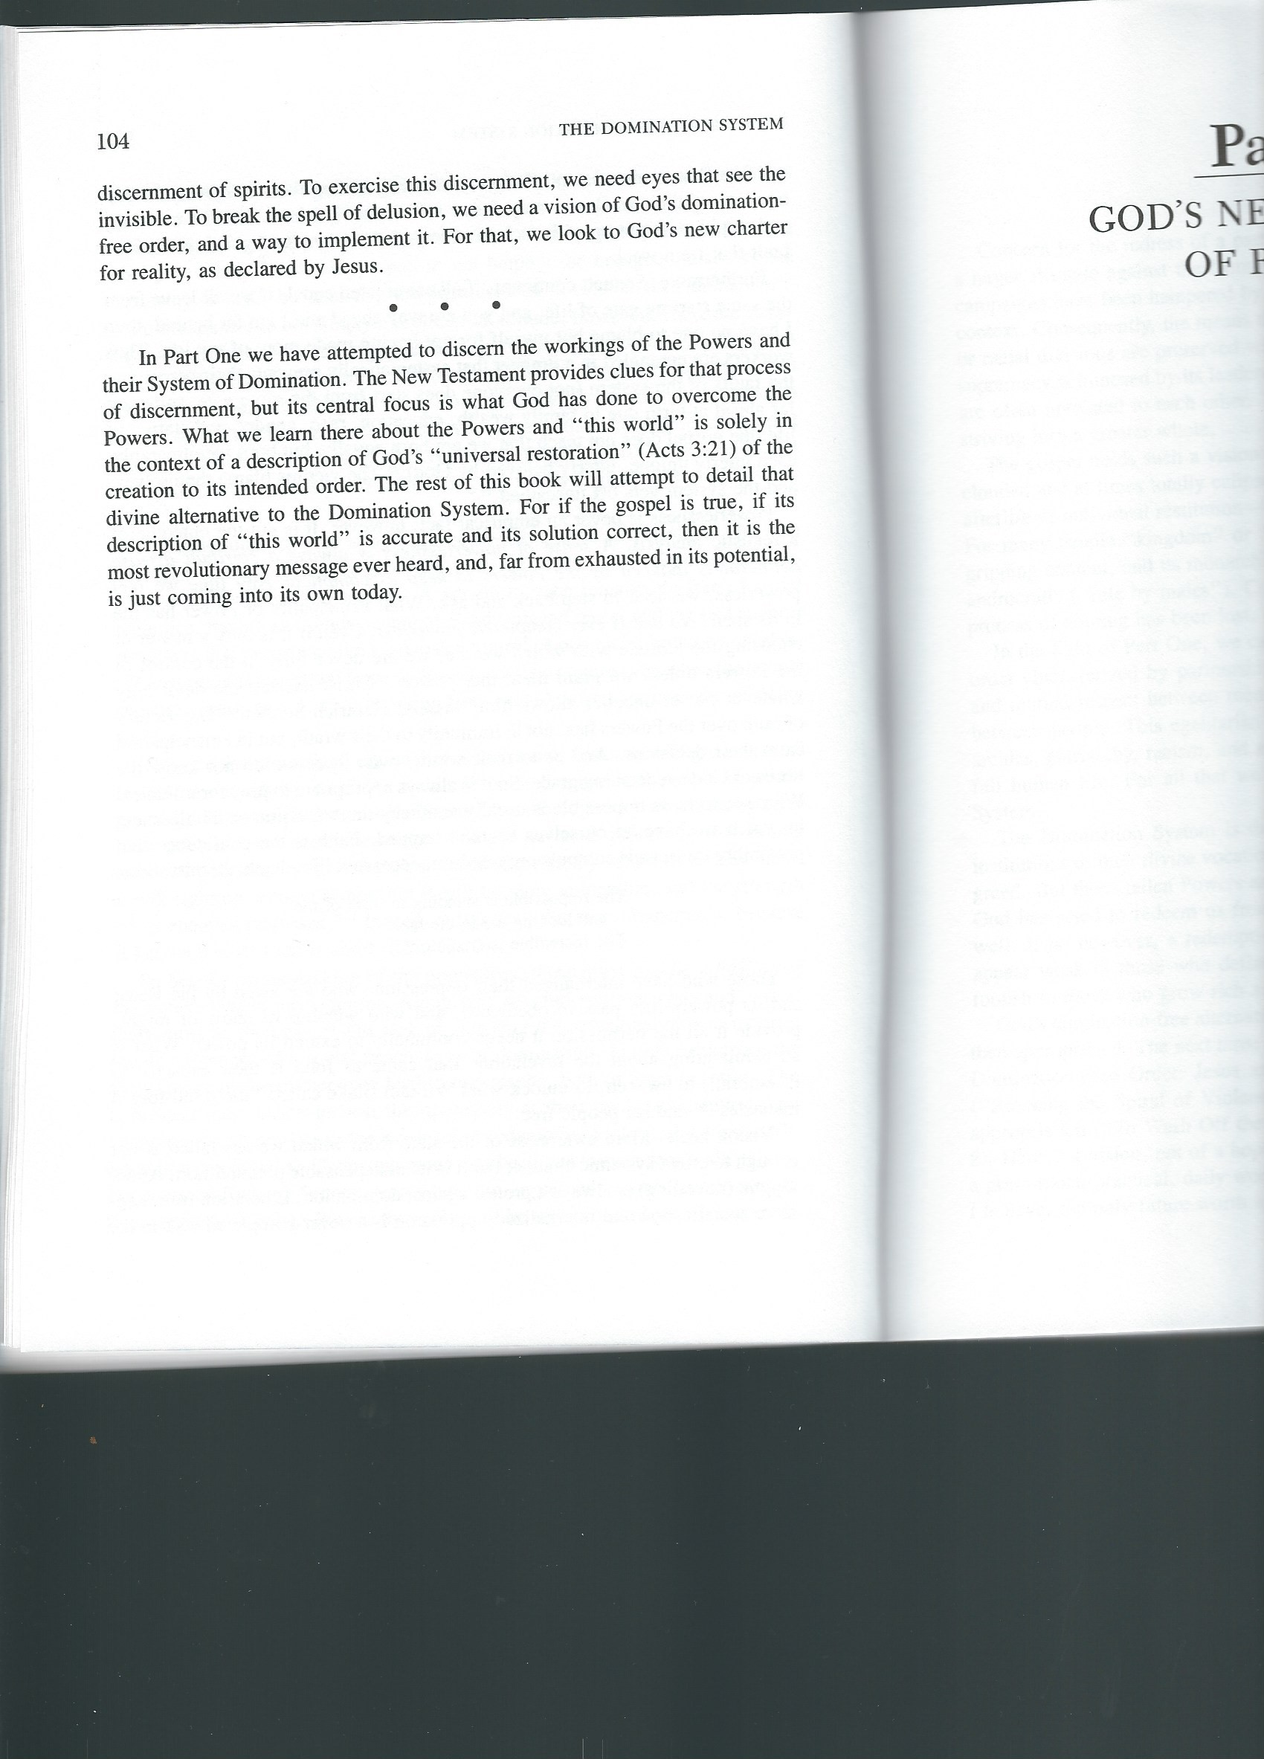

Walter Wink, Engaging the Powers: Discernment and resistance in a World of Domination. Fortress Press, Minneapolis, 1992, pages 87-104.

