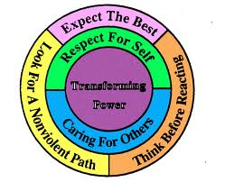
Alternatives to Violence Project
Transforming Stopping Daily Hostility & Harassment

Friday ~Saturday 8:45am-5pm~January 27 & 28
5 Longfellow Park, Cambridge, MA

The Alternatives to Violence Project began in 1975. An inmate group at Green Haven Prison in New York, was engaged in work with youth gangs. They sought assistance from the Quaker Project on Community Conflict, and from the partnership of inmates and Quakers, AVP was born. AVP is in demand in schools, prisons and youth groups. AVP conducts programs in 35 US states and over 45 countries. AVP has shaped the Reconciliation process in South Africa and in Rwanda. How can we emerge from the cycle of emotional and structural violence?
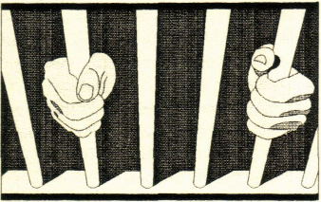
You will learn: Cycles of Violence,
Talking with people with different viewpoints,
Interrupting attacks before they get out of hand.

Register before1/9/17 minga@thebornes.org Sponsored by Cambridge Friends
Organizers~ John Bach, Minga Claggett-Borne & Gail Rogers
Suggested donation $20. Pay more or less as able. Food provided.

