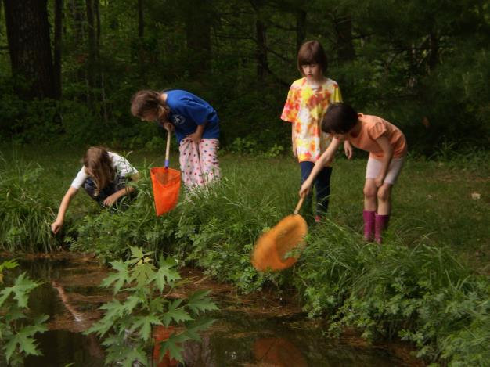

**Please Join Us!**

2017 Family Retreat, Memorial Day Weekend

Saturday, May 27 – Monday, May 29

Notre Dame Spiritual Center, Alfred, Maine

Come together to share fellowship, outdoor play, nature walks, and worship in beautiful Alfred, Maine. Our annual retreat begins at lunch on Saturday at noon, ending early afternoon on Monday.

Adults and children age 12 and up: $150 for the weekend. Children age 5-11: $75; Children 4 and under: no charge.

**Registration Form**

Name of Adult(s) Attending: ___________________________________________________

Name(s) & Age(s) of Children Attending: ___________________________________________________

Email Address(es): _____________________ _Phone # ______________________________________Phone#

Vegetarian: □ Yes □ No Rides: □ Needed □ Offered (___ # can take) Mail or drop off form & check at the office:

Friends Meeting at Cambridge 5 Longfellow Park, Cambridge, MA 02138 Checks payable to: Friends Meeting at Cambridge

Payment Summary: Amount I can contribute $________________ Donation towards Scholarships $____________ Scholarship Amount Requested: $____________

TOTAL OF CHECK PAID: $_______________

**Safety Commitment:** Parents/guardians, please note that we take responsibility for our own children’s safety throughout the weekend. FMC does not provide official childcare workers for this retreat. Also, since it is an intergenerational, community-building event, attendees (adult and youth) must commit to abstaining from the use of alcohol/illegal drugs.

In addition to these basic expectations, on our first day together we will have a community meeting to discuss how we can all ensure a safe and fun weekend for all.

*Any questions, please contact: Annie Myers 617-232-0937 anniemyers5@gmail.com REGISTRATION DEADLINE: Sunday, May 21, 2017