# Cognitive Dissonance

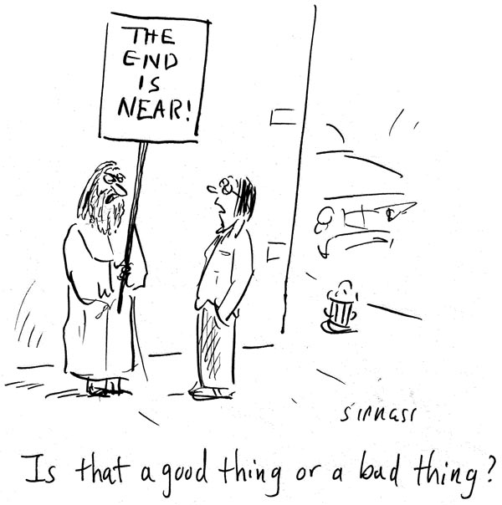

According to the domination system, the end of the world is the end of everything. It is a foolish idea believed by the religious fringe. After all the predictions, it hasn’t happened, right?

The end of the era of domination and violence is coming

According to Wink, the end of the “world” is the end of the domination system.

According to the myth of redemptive violence, the domination system maintains order in the face of chaos. In fact, the domination system has created the very chaos that could bring the end to everything.